**HW Linear Programming**

**Name :** Sahand Sabour **Student ID:** 2020280401

1. **Solving the following linear program using simplex method**



The above equations could be rewritten in augmented form.

$$\left\{\begin{aligned}3x_{1}+4x_{2}+x_{3}+x_{4}=2 \\ x_{1}+3x_{2}+2x_{3}+x_{5}=1 \\ x_{1}, x_{2},x_{3},x_{4},x_{5} ≥0\end{aligned}\right.$$

Accordingly, the table would be as follows

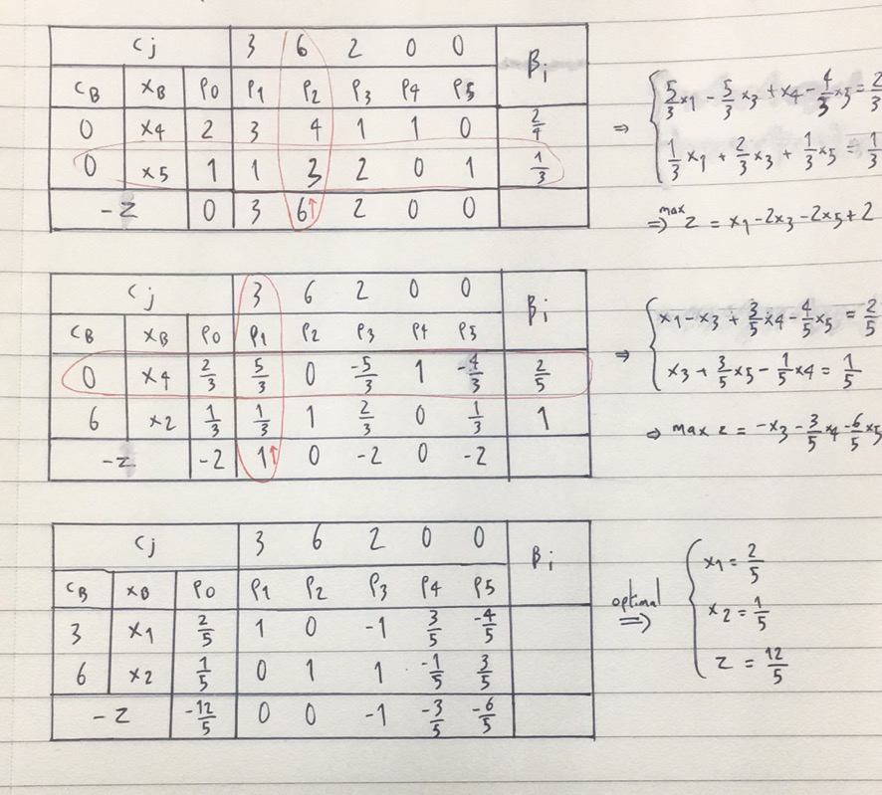

Let $x_{2}$ be a basic variable. Accordingly, by modifying the above equations, we have

$$\left\{\begin{aligned}9x_{1}+12x_{2}+3x_{3}+3x_{4}=6 \\ {−4x}_{1}−12x_{2}−8x_{3}−4x_{5}=−4 \\ {\frac{1}{3}x}_{1}+x_{2}+\frac{2}{3}x_{3}+\frac{1}{3}x_{5}=\frac{1}{3}\end{aligned}\right.$$

Simplifying the top two equation gives

$$\left\{\begin{matrix}{\frac{5}{3}x}_{1}−\frac{5}{3}x_{3}+x_{4}−\frac{4}{3}x_{5}=\frac{2}{3} \\ {\frac{1}{3}x}_{1}+x_{2}+\frac{2}{3}x_{3}+\frac{1}{3}x_{5}=\frac{1}{3}\end{matrix}\right.$$

And the program can be written as



$$max Z =x_{1}−2x_{3}−2x_{5}+2$$

Let $x_{1}$ be a basic variable. Accordingly, by modifying the above equations, we have

$$\left\{\begin{aligned}x_{1}−x_{3}+\frac{3}{5}x_{4}−\frac{4}{5}x_{5}=\frac{2}{5} \\ {\frac{5}{3}x}_{1}−\frac{5}{3}x_{3}+x_{4}−\frac{4}{3}x_{5}=\frac{2}{3} \\ {−\frac{5}{3}x}_{1}−5x_{2}−\frac{10}{3}x_{3}−\frac{5}{3}x_{5}=\frac{−5}{3}\end{aligned}\right.$$

Simplifying the lower two equation gives

$$\left\{\begin{matrix}x_{1}−x_{3}+\frac{3}{5}x_{4}−\frac{4}{5}x_{5}=\frac{2}{5} \\ x_{3}−\frac{1}{5}x_{4}+\frac{3}{3}x_{5}=\frac{1}{5}\end{matrix}\right.$$

And the program can be written as



$$max Z =−x_{3}−\frac{3}{5}x_{4}−\frac{6}{5}x_{5}+\frac{12}{5}$$

Therefore, the optimal solution would be

$$\begin{matrix}x_{1}=\frac{2}{5} \\ x_{2}=\frac{1}{5} \\ Z=\frac{12}{5}\end{matrix}$$